Tutorial 1 — Jupiter
Processing a Jupiter image with Kepler
Image: 2026-01-20 · ZWO ASI 678MC color camera · Drizzle ×1.5 · 900×900 px

About this Image
This is a color image of Jupiter captured in January 2026 near opposition, when Jupiter was large and well-placed. It was recorded with a ZWO ASI 678MC color video camera and the best frames were aligned and stacked in Autostakkert! 4 to produce a sharp color image ready for processing. The 1.5× drizzle stacking has enlarged the disk to approximately 400 pixels across, revealing the broad equatorial belt system. Note the small dark dot near center-left: a moon shadow transit crossing the South Equatorial Belt.
Raw from stacking software, the image arrives with south at the top — the standard orientation from a Cassegrain or SCT telescope at the eyepiece. We will sharpen it and then rotate 93° clockwise to place north up, matching published planetary atlases.

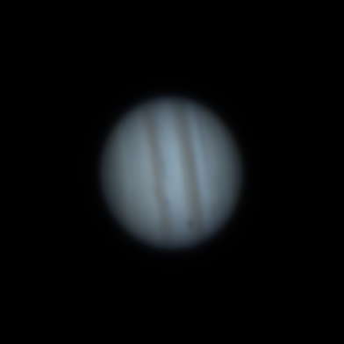 | 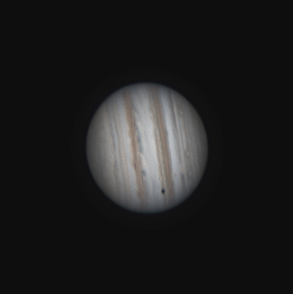 | 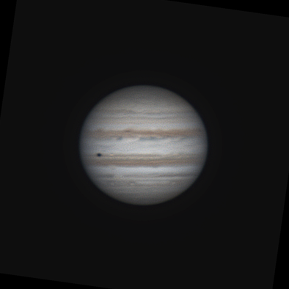
As loaded (south up) | After Wavelet + FFT + RGB  + Curves + CLAHE | Rotated 93° CW — north up

Step 1 — Open the Image
Click Open Image and select the Jupiter TIFF. Kepler loads the 16-bit file at full precision. The PROCESSED panel will show the unprocessed image. You should see a soft disc with hints of the belt structure but little detail yet.

Step 2 — Wavelet Sharpening
Go to the Wavelet tab. Jupiter's belt system spans a range of spatial scales, so we use all three layers. Use the settings below:

Setting | Value | Notes
Layer 1 Sharpen | 200 | Finest detail — grain in belts, limb sharpness
Layer 1 SharpenFilter | 0.146 | Click Autosize to set all three layers automatically
Layer 2 Sharpen | 120 | Belt boundaries, filamentary structure
Layer 3 Sharpen | 60 | Large-scale equatorial zones
Convolve | LRGB | Full two-channel mode — strongest result
Color Model | oklab | Default — leave unchanged

Tip: Click Autosize Filter to set SharpenFilter (and Decomp σ) for all three layers to the calibrated defaults automatically.

Step 3 — FFT Denoise
Enable the FFT tab. Jupiter color data at this gain level can have moderate high-frequency noise. POST mode cleans up after sharpening.

Setting | Value | Notes
Enable | On (POST) | Applied after all wavelet sharpening
Start % | 20 | Rolloff begins at 20% of Nyquist
End % | 70 | Full attenuation at 70% of Nyquist
Curve | 75 | Moderately aggressive rolloff shape

Tip: Click Auto Denoise first — it will estimate Start and End from the image's power spectrum. The values above are a good manual starting point if Auto Denoise gives a start above 40%.

Step 4 — RGB Color
Use the RGB tab to refine the color balance and bring out Jupiter's characteristic warm tones:

Setting | Value | Notes
All Gain | 50 (default) | Starting point — adjust per channel to taste
Saturation | 55 | Slight increase brings out the warm belt tones
Vibrance | 52 | Gently lifts muted areas
Brightness | 0 | Leave unchanged
Contrast | 1.05 | Very slight contrast boost

Tip: Click Auto RGB Balance first to correct any color cast from the camera sensor. Then fine-tune per channel — Jupiter typically benefits from a slight boost in Red and reduction in Blue to bring out the warm equatorial belt tones.

Step 5 — Tools: Levels & Curves and CLAHE
The Tools tab lets you refine tonal contrast and enhance local detail after color balance. For Jupiter, the goal is to deepen the contrast between the bright zones and dark belts, and bring out subtle color in the equatorial region.

Levels & Curves
In the Tools tab, use the All channel controls with these starting values:
Setting | Value | Notes
Black point | 0.02–0.04 | Clips the sky background to pure black and lifts disk contrast slightly.
White point | 0.85–0.95 | Compresses the highlights slightly — prevents the bright zones from washing out.
Gamma | 1.05–1.10 | Lifts midtones gently to reveal subtle belt color and cloud texture.
Then add a gentle S-curve on the tone curve canvas: drag the shadow anchor (bottom-left) slightly down and to the right, and the highlight anchor (top-right) slightly up and to the left. This deepens the belts and brightens the zones for a more vivid result.
Tip: Keep the S-curve subtle — large adjustments on a planetary image quickly look unnatural. A curve where the midpoint moves by 5–10% is usually enough.

CLAHE
Enable CLAHE with these settings to bring out low-contrast detail in the belt and zone boundaries:
Setting | Value | Notes
Clip Limit | 1.0–2.0 | Higher than the default for Jupiter — the disk has enough tonal range to support stronger local contrast.
Tile Grid | 4 | Default — gives good local contrast across the disk without tile artefacts.
Strength | 0.05–0.10 | Keep low. Even a small amount of CLAHE is clearly visible on Jupiter.
Apply to | Luminance only | Recommended — avoids color shifts in the belt regions.

Step 6 — Rotate to North Up
Raw planetary images from a Cassegrain or SCT telescope arrive with south at the top. To match published Jupiter maps — where the North Equatorial Belt (NEB, the darker of the two prominent belts) is in the upper half — rotate 93° clockwise.
How to identify south-up: look for the NEB (a prominent dark belt). If it is in the lower half of the disk, the image is south-up. After a 93° clockwise rotation it will appear in the upper half, correct for north-up orientation.

Use the Rotate row in the PREVIEW section just below the zoom controls:
- Type 93 in the Rotate spinbox — or click the 90° preset button then adjust to 93.
- The PROCESSED canvas updates instantly. Check the NEB belt is in the upper half.
- Click Export Image to save. The rotation is included in the exported file.

The rotation also syncs automatically to the Batch tab — if you later run a batch, the same 93° rotation will be applied to every file without any additional setup.

Tip: The Rotate spinbox in the PREVIEW section updates the image instantly. Confirm the NEB belt is in the upper half before exporting.

Step 7 — Export
Click Export Image — a small format picker appears first. Choose TIFF 16-bit for maximum quality (preserves 16-bit depth) or PNG for sharing. The file save dialog opens with the correct extension pre-filled. The exported file includes all processing and any preview rotation.

What to Look For
- NEB (North Equatorial Belt): broad dark band in the upper hemisphere after rotation.
- SEB (South Equatorial Belt): second dark band in the lower hemisphere.
- Equatorial Zone (EZ): the bright creamy band between the NEB and SEB.
- Moon shadow: the small dark dot visible in this image is a Galilean moon's shadow transiting the disk — appearing near the SEB in the south-up raw image, moving to the north side after rotation.
- Limb darkening: the edges of the disk appear slightly dimmer — this is real and will be enhanced by the sharpening.

Tutorial 2 — Saturn
Processing a Saturn image with Kepler
Image: 2025-12-01 · ZWO ASI 678MC color camera · Drizzle ×1.5 · 720×960 px

About this Image
This color image of Saturn was taken in December 2025, a special period: Saturn's rings were passing through edge-on as seen from Earth (the March 2025 ring plane crossing), so the ring tilt is very shallow — only a few degrees. The rings appear nearly as a thin line crossing the disk rather than the classic open-oval display. Captured with a ZWO ASI 678MC color video camera and stacked in Autostakkert! 4.
The image was captured in blue/UV light, which enhances Saturn's polar hazing and banding. The disk appears bluish-white, and a faint moon (likely Rhea or Tethys) is visible as a small dot beside the rings. The image is 720×960 pixels — taller than wide, as Saturn's extended ring system is oriented vertically in this nearly edge-on view.

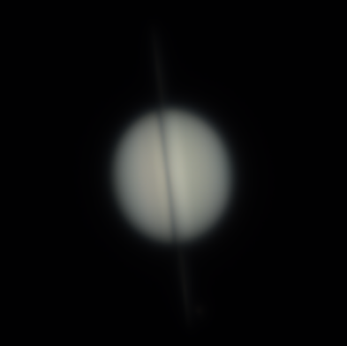 | 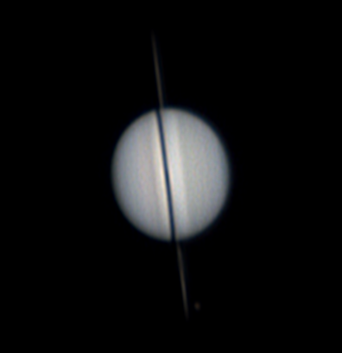 | 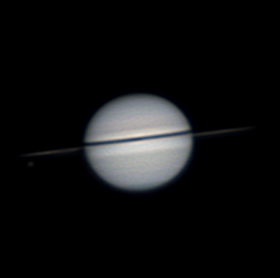
As loaded (south up, rings near edge-on) | After Wavelet + FFT + RGB  + Curves + CLAHE | Rotated 93° CW — north up

Step 1 — Open the Image
Click Open Image and select the Saturn TIFF. Kepler loads the 16-bit file. The disk will appear small relative to the frame because of the extended ring system. Note the near-vertical ring line crossing the disk.

Step 2 — Wavelet Sharpening
Saturn at ring edge-on presents delicate structure: subtle atmospheric banding and the razor-thin ring silhouette. Use gentler sharpening than Jupiter to avoid over-amplifying noise in the color data.

Setting | Value | Notes
Layer 1 Sharpen | 100 | Moderate — Saturn color data rewards a gentler touch
Layer 1 SharpenFilter | 0.146 | Autosize default — click Autosize to set all layers
Layer 2 Sharpen | 50 | Belt and ring structure at medium scale
Layer 3 Sharpen | 25 | Large disk contrast — use gently
Convolve | LRGB | Full mode
Pre-Smooth σ | 0.5 | Optional: adds slight pre-blur on noisy blue data

Tip: If the ring line looks ragged or shows dark artefact dips after sharpening, enable De-rind on the limb with a small Edge value (4–6 px). The ring crossing creates a sharp edge that can produce ringing.

Step 3 — FFT Denoise
Saturn color data at high gain benefits from FFT denoising. The noise floor sits clearly above the signal content, making it easy to find a good cutoff.

Setting | Value | Notes
Enable | On (POST) | Applied after all sharpening
Start % | 20 | Slightly conservative — blue is noisier
End % | 70 | Full cutoff at 70% Nyquist
Curve | 85 | Moderate to High rolloff

Tip: Click Auto Denoise and compare the suggested Start to 25. On blue/UV data Auto Denoise usually places the start between 20–30%, which is appropriate.

Step 4 — RGB Color
Use the RGB tab to bring out Saturn's characteristic pale gold color. The blue channel in the stacked color image often carries more noise, so keep adjustments subtle.

Setting | Value | Notes
Red Gain | 45 | Slightly reduce red for cool blue tint
Green Gain | 50 | Leave near unity
Blue Gain | 58 | Lift to emphasize UV/blue content
Saturation | 52 | Slight increase — Saturn is subtle in blue light
Vibrance | 50 | Default

Step 5 — Tools: Levels & Curves and CLAHE
Saturn's disk is lower contrast than Jupiter — the tonal range between the bright rings, pale disk, and dark sky is narrower. The Tools tab can carefully lift this contrast without making the image look processed.

Levels & Curves
Use the All channel controls:
Setting | Value | Notes
Black point | 0.01–0.03 | Gently clips the sky background. Keep very low — Saturn's limb is already quite dark.
White point | 0.80–0.90 | Compresses highlights to prevent the bright rings from blowing out.
Gamma | 1.05–1.15 | Lifts the disk midtones to bring out the subtle equatorial banding.
A gentle curve lift in the lower midtones (drag the 0.25 area upward slightly) can reveal the Cassini Division and ring shadow detail without over-brightening the disk.
Tip: The rings and disk have very different brightness levels. If a single tone curve clips either the rings or the disk, switch to per-channel mode (R/G/B) and adjust each channel individually.

CLAHE
CLAHE is particularly useful for Saturn to reveal the subtle atmospheric banding:
Setting | Value | Notes
Clip Limit | 0.5–1.5 | Keep at the lower end — Saturn's disk is delicate and over-enhancement creates noise.
Tile Grid | 4 | Default.
Strength | 0.03–0.07 | Very subtle — Saturn's banding responds well to even minimal CLAHE.
Apply to | Luminance only | Essential for Saturn — RGB mode can create unnatural color banding.

Step 6 — Rotate to North Up
As with all telescope planetary images from the northern hemisphere, this image arrives south-up. In the unrotated image, Saturn's north polar region (which is slightly darker/hazier in blue light) is at the bottom. After 93° clockwise rotation, north is at the top — the ring shadow falls on the southern hemisphere, now below center.
How to identify south-up with rings near edge-on: look at which side of the disk the ring shadow falls on. Saturn's rings were south of the equatorial plane as seen from Earth in late 2025, so the shadow cast by the rings onto the disk falls onto the southern hemisphere. In a south-up image this shadow appears above center; after 93° clockwise rotation it is below center.

Use the Rotate row in the PREVIEW section:
- Type 93 in the Rotate spinbox, or click the 90° preset then adjust to 93.
- The PROCESSED canvas updates instantly — confirm the ring is now horizontal.
- Click Export Image to save with the rotation applied.

Note: The ring line is an excellent orientation reference. In north-up orientation from the northern hemisphere in late 2025, the ring extends from lower-left to upper-right when the rings are slightly open. If yours goes from upper-left to lower-right, the image still needs a 93° clockwise rotation.

Step 7 — Export
Click Export Image and select TIFF 16-bit from the format picker to preserve full bit depth. The format picker appears before the file save dialog — choose your format there, then name and save the file.

What to Look For
- Ring plane: the thin ring line crossing the disk. At this near-edge-on geometry, the gap between the A and B rings may be visible as a subtle dark line within the ring.
- Ring shadow: a dark band across the disk where the rings block sunlight. Locating this confirms orientation.
- Polar hexagon / haze: in blue/UV light, Saturn's north polar region often appears distinctly darker — a polar haze cap.
- Equatorial belt banding: subtle darker bands visible crossing the disk horizontally (in north-up orientation).
- Moon: the small point of light near the ring line is a Saturnian moon, identifiable by comparing to an ephemeris for the date (2025-12-01).

Tutorial 3 — Mars
Processing a Mars image with Kepler
Image: 2025-01-18 · ZWO ASI 678MC color camera · Drizzle ×1.5 · 600×600 px

About this Image
This color image of Mars was taken on 18 January 2025, very close to opposition (11 January 2025), when Mars was at its largest apparent size and fully illuminated. Captured with a ZWO ASI 678MC color video camera and stacked in Autostakkert! 4. Martian albedo features — dark volcanic plains and bright dusty highlands — show strong contrast.
The 1.5× drizzle has expanded the disk to approximately 140 pixels across. The bright white region is the south polar cap (SPC), prominent in summer. The large dark area occupying most of the upper-left quadrant (in the south-up raw image) is Acidalia Planitia, one of the most recognisable features on the Martian surface.
Because Mars has a small apparent disk even at opposition, getting clean detail requires careful sharpening without over-amplification. The color data rewards a measured approach.

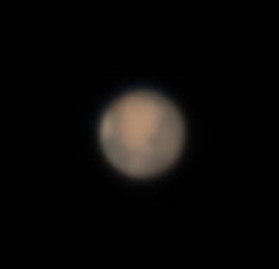 | 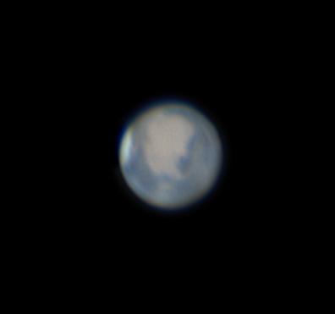 | 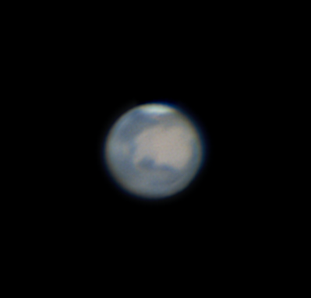
As loaded (south up) | After Wavelet + FFT + RGB  + Curves + CLAHE | Rotated 93° CW — north up + De-rind

Step 1 — Open the Image
Click Open Image and select the Mars TIFF. The disk is relatively small within the 600×600 frame — this is normal for a drizzled Mars capture. You can use the Zoom slider to enlarge the preview for easier evaluation.

Step 2 — Wavelet Sharpening
Mars presents a challenge: the disk is small (about 140 px across), so aggressive Layer 3 sharpening applies correction to features larger than the disk itself, which is counterproductive. Keep Layer 3 low and focus sharpening energy on Layers 1 and 2.

Setting | Value | Notes
Layer 1 Sharpen | 180 | Fine detail — dust storm edges, polar cap boundary
Layer 1 SharpenFilter | 0.146 | Autosize default — click Autosize to set all layers
Layer 2 Sharpen | 100 | Albedo feature boundaries at belt scale
Layer 3 Sharpen | 30 | Keep low — Mars disk is not large enough for Layer 3 to be useful
Convolve | LRGB | Full mode

Tip: If the polar cap boundary shows a dark ring (halo) after sharpening, enable De-rind with Edge = 8 px, Feather = 4 px. The sharp contrast between the bright polar cap and dark surroundings is a common ringing trigger.

Step 3 — FFT Denoise
Mars color data at moderate gain is relatively clean. A light FFT pass removes sharpening grain without softening the strong albedo features.

Setting | Value | Notes
Enable | On (POST) | Applied after all sharpening
Start % | 22 | Mars data might be relatively clean — can start in the 20 to 40 range
End % | 70 | Standard cutoff
Curve | 60 | Moderately aggressive

Tip: On a small disk like Mars, the FFT operates on mostly black sky pixels. Verify the power spectrum shows a clear signal peak — if it looks flat, the disk may be too small to drive a meaningful spectral estimate, and Auto Denoise may be less reliable. Use the manual values above as a starting point.

Step 4 — RGB Color
Use the RGB tab to bring out the characteristic rusty Mars appearance. The south polar cap should appear bright white, and Acidalia Planitia dark gray-brown.

Setting | Value | Notes
Red Gain | 58 | Lift red channel for the characteristic rust color
Green Gain | 48 | Slightly reduce green
Blue Gain | 44 | Reduce blue — Mars is warm in red light
Saturation | 58 | Stronger increase — Mars color contrast is striking
Vibrance | 55 | Helps lift muted ochre mid-tones
Brightness | 5 | Slight lift to brighten the disk

Tip: Click Auto RGB Balance first. For Mars it will typically push Red gain up and reduce Blue/Green, giving you most of the characteristic rust color in one click. Fine-tune from there.

Step 5 — Rotate to North Up
Mars from a northern hemisphere telescope arrives south-up. The south polar cap, when visible and prominent, appears at the top of the unrotated image. After 93° clockwise rotation, the SPC moves to the bottom — correct for north-up orientation.
How to identify south-up on Mars: the south polar cap is the bright white region. In the raw south-up image (January 2025, southern summer on Mars), the SPC is prominent and appears at the top. Large dark albedo features such as Acidalia Planitia appear in the lower-right of the north-up image — upper-left in the raw south-up image. After 93° clockwise rotation, the SPC is at the bottom and Acidalia is upper-left in north-up convention.

Use the Rotate row in the PREVIEW section:
- Type 93 in the Rotate spinbox, or click the 90° preset then adjust to 93.
- The PROCESSED canvas updates instantly — confirm the south polar cap is now at the bottom.
- Click Export Image to save with the rotation applied.

Tip: Use the Rotation Preview thumbnail to verify the south polar cap is now at the bottom before running. The bright white cap is the most unambiguous orientation marker on Mars.

Step 6 — De-rind
Mars has a small disk (~123 px diameter in this image) but wavelet sharpening at Layer 1 Sharpen 180 still produces a faint limb halo. A light de-rind pass removes it cleanly. Because the disk is small, keep all settings conservative to avoid over-correcting.

In the De-rind tab, click Auto De-rind. Enable Show Mask overlay to verify the ring mask sits on the limb halo without overlapping the polar cap or the dark albedo features near the limb.

Setting | Value | Notes
Edge | 40–50 | Auto De-rind typically finds 40–50 for a small Mars disk. Reduce if the mask overlaps Acidalia Planitia.
Feather | 15–20 | Keep moderate — the disk is small so a wide feather blends into the disk center.
Smooth | 20–25 | Sufficient for Mars. Higher values can soften the limb definition.
Inset | 2–4% | A small inset prevents the correction touching the polar cap bright edge.
Dark Edge | Off | Leave off unless the limb appears darker than expected after correction.
After applying, zoom into the limb region in the preview and compare ORIGINAL vs PROCESSED. The halo should be reduced without the south polar cap or Hellas Basin appearing dimmer than they should.
Tip: For Mars, less is more with De-rind. The disk is small enough that aggressive ring correction can make the entire limb look unnaturally flat. If in doubt, reduce Edge by 5 and check again.

Step 7 — Tools: Levels & Curves and CLAHE
Mars has the highest native contrast of the three planets — albedo features are already strong. The Tools tab here is used mainly to balance the polar cap brightness against the dark plains, rather than to lift contrast overall.

Levels & Curves
Use the All channel controls:
Setting | Value | Notes
Black point | 0.03–0.06 | Clips the dark sky and crushes the darkest albedo features (Acidalia Planitia) toward black for a clean look.
White point | 0.90–1.00 | Leave near the default — the south polar cap brightness is the natural white reference.
Gamma | 0.95–1.05 | Usually minimal adjustment needed for Mars. A value slightly below 1.0 can deepen the dark plains contrast.
A custom curve is most useful for Mars: gently lift the shadow-to-midtone transition (the 0.1–0.3 range) to reveal detail in the dark volcanic plains, while holding the highlights flat to preserve the polar cap.
Tip: Try per-channel curves for Mars — a slight lift in the Red channel curve midtones and a corresponding suppression in Blue brings out the characteristic rust color while keeping the polar cap clean white.

CLAHE
CLAHE on Mars is optional — the strong albedo contrast often means it isn't needed. If you do use it:
Setting | Value | Notes
Clip Limit | 0.5–1.0 | Keep low — Mars albedo features are already high contrast and CLAHE can easily over-process.
Tile Grid | 4 | Default.
Strength | 0.03–0.05 | Very subtle. Check the polar cap doesn't develop a blocky halo.
Apply to | Luminance only | Recommended.

Step 8 — Export
Click Export Image and select TIFF 16-bit from the format picker for maximum quality, or PNG for sharing. The format picker appears before the file dialog — select the format there, then name and save.

What to Look For
- South Polar Cap (SPC): the brilliant white region at the bottom after north-up rotation. In January 2025 this was still substantial — southern summer was underway.
- Acidalia Planitia: the large dark region in the upper-left quadrant (north-up). One of the most prominent dark features on Mars, part of the 'dark collar' around the north pole.
- Chryse Planitia: the slightly brighter patch adjacent to Acidalia, center-top in north-up orientation. The Viking 1 landing site.
- Polar cap boundary: a high-contrast ring around the SPC. This is a real feature but is a common trigger for sharpening ringing — use De-rind if a halo appears here.
- Limb brightening: Mars sometimes shows a slightly brighter limb due to atmospheric haze. This is real and should not be mistaken for a sharpening artefact.
- arpening artefact.

